**Musa Haji**

**230701391**

**EX NO: 4**

**CREATE USER STORIES**

Aim:

To create User Stories

THEORY

A user story is an informal, general explanation of a software feature written

from the perspective of the end user. Its purpose is to articulate how a software feature

will provide value to the customer.

User story template

"As a [role], I [want to], [so that]."

Procedure:

1. Open your web browser and go to the Azure website:

https://azure.microsoft.com/en-in Sign in using your Microsoft account

credentials. If you don't have an account, you'll need to create one.

2. If you don’t have a Microsoft account, you can sign up for

https://signup.live.com/?lic=1   
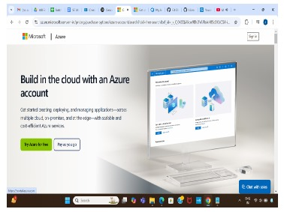

3. Azure home page   
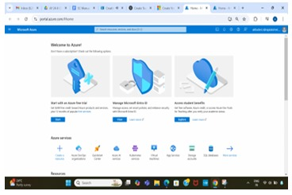

4. Open DevOps environment in the Azure platform by typing Azure DevOps Organizations in the search bar.

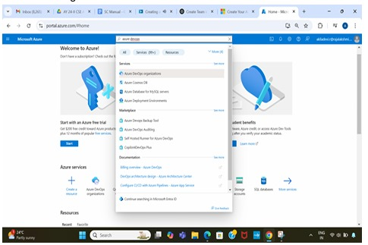

5. Click on the My Azure DevOps Organization link and create an organization and you should be taken to the Azure DevOps Organization Home page.

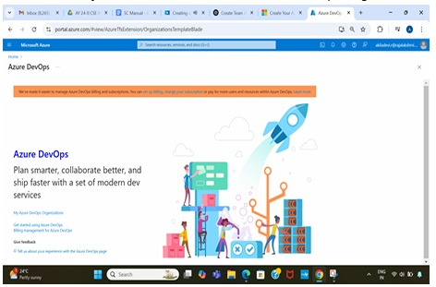

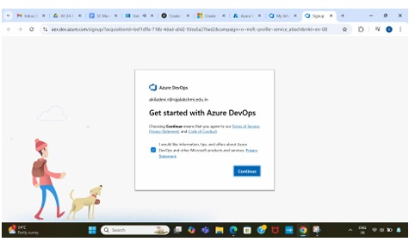

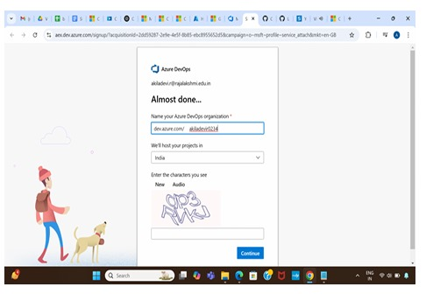

6. Create the First Project in Your Organization After the organization is set up, you’ll need to create your first project. This is where you'll begin to manage code, pipelines, work items, and more.

i.On the organization’s Home page, click on the New Project button.

ii.Enter the project name, description, and visibility options:

○ Name: Choose a name for the project (e.g., LMS).

○ Description: Optionally, add a description to provide more context about

the project.

○ Visibility: Choose whether you want the project to be Private

(accessible only to those invited) or Public (accessible to anyone).

iii.Once you’ve filled out the details, click Create to set up your first project.

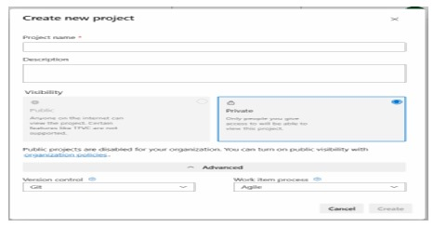

7. Once logged in, ensure you are in the correct organization. If you're part of multiple organizations, you can switch between them from the top left corner (next to your user profile). Click on the Organization name, and you should be taken to the Azure DevOps Organization Home page.

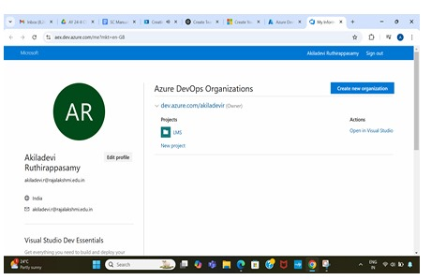

8. Project dashboard

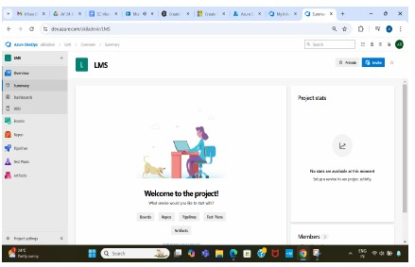

9. To manage user stories

a. From the left-hand navigation menu, click on Boards. This will take you to the main Boards page, where you can manage work items, backlogs, and sprints.

b. On the work items page, you'll see the option to Add a work item at the top. Alternatively, you can find a + button or Add New Work Item depending on the view you're in. From the Add a work item dropdown, select User Story. This will open a form to enter details for the new User Story.

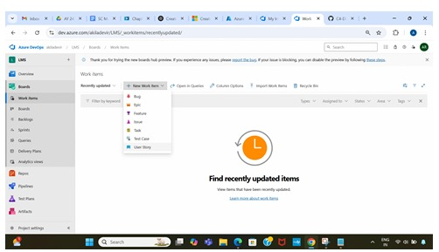

10. Fill in User Story Details

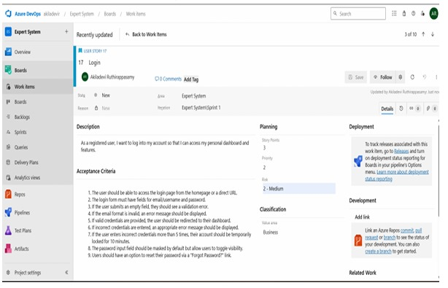

Result:

The user story was written successfully